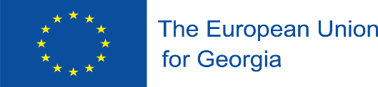


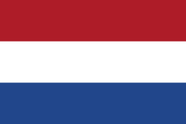


This project is funded by the European Union

“Strengthening Blood Safety System in Georgia”

Activity 2.1.1. Closing discussions on the establishment of the NCA as required by EU Blood Directives

17 July 2020

STEs:

Ms. Laimute Stoniene, Head of Quality Assurance Department, National Blood Center, Lithuania;
Ms. Agne Kaminskiene, Lawyer, National Blood Center, Lithuania;
Mr. W.Martin Smid, Managing Director of Sanquin Consulting Service, Sanquin Blood Supply Foundation, Netherlands;
Mr. Wim de Kort, Professor of Donor Health Care, University of Amsterdam, Netherlands;
Ms. Olenka van Ardenne, Senior Legal Counsel, Sanquin Blood Supply Foundation, Netherlands.

Friday, 17 July, 2020

14:00 – 14:05 | Adjustment of technical issues (voice, image)
14:05 – 14:30 | Tentative functionalities of the future blood safety system monitoring organization or unit (under three possible institutions : MoH, NCDC, Regulation Agency – STEs (LT, NL)
14:30 – 15:00 | Potential challenges if the future NCA operated under each of these bodies: MoH, NCDC, Regulation Agency – STEs (LT, NL)
15:00 – 15:30 | Questions - Answers
 | End of the Teleconference

